**“Designing and Building an Autonomous Robot System Prototype”**

**Computer Science & Engineering**

**University of Rajshahi**



**Submitted By**

**Md. Nazmul Hasan**

**ID:2111176131**

**Session:2020-21**

**Project Advisor**

**Prof. Dr. Bimal Kumar Pramanik**

**“Designing and Building an Autonomous Robot System Prototype”**

Table of Contents

**Abstract 1**

**1** **Introduction 2**

1.1 General Description 2

1.2 Literature Survey 2

**2** **Methodology 2**

2.1 System Architecture 2

2.2 Improvement of projected system over existing system. 4

**3** **Time Schedule: 4**

**4** **Project Cost : 5**

**5** **Conclusion 5**

**6** **References 6**

# **Abstract**

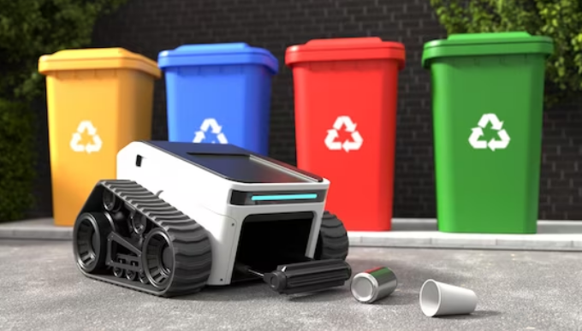The project envisions the creation of an autonomous robotic system tailored for intelligent waste collection in a seminar library. The primary objective is to develop an innovative solution that autonomously navigates through predefined routes, specifically entering designated rooms (room 120 and 122) to adeptly collect diverse waste materials. The targeted items include paper, unused pencils, pens, erasers, and water bottles.

**Fig 1.** Garbage Collector

A waste management robot mission is envisioned to revolutionize the process of waste disposal and recycling through the development and deployment of sophisticated robotic systems. The mission's primary objective is to create robots capable of autonomously collecting and sorting waste materials based on their types. Employing advanced technologies such as computer vision, machine learning, and robotic arms, these robots will navigate predefined areas, such as neighborhoods and industrial zones, efficiently covering waste collection and recycling zones.

# **1. Introduction**

## 1.1 General Description

A waste management robot is an advanced robotic system designed for autonomous waste handling tasks, including collection, sorting, and recycling. Utilizing cutting-edge technologies such as computer vision, machine learning, and sensors, these robots can autonomously navigate designated areas, identify various waste materials, and sort them based on predefined categories. The primary functions encompass efficient waste collection, sorting materials accurately, and depositing recyclables into appropriate containers.

## 1.2 Literature Survey

We started this project by looking at how robots currently work on their own and how we deal with garbage. Our study showed that we can use technology to make garbage collection better and more environmentally friendly [1]. So, we're using ideas from existing robots, sensors, and garbage management methods to design and build our own robot.

# 

# **2. Methodology**

**Fig 2. Block Diagram of Garbage Collector**

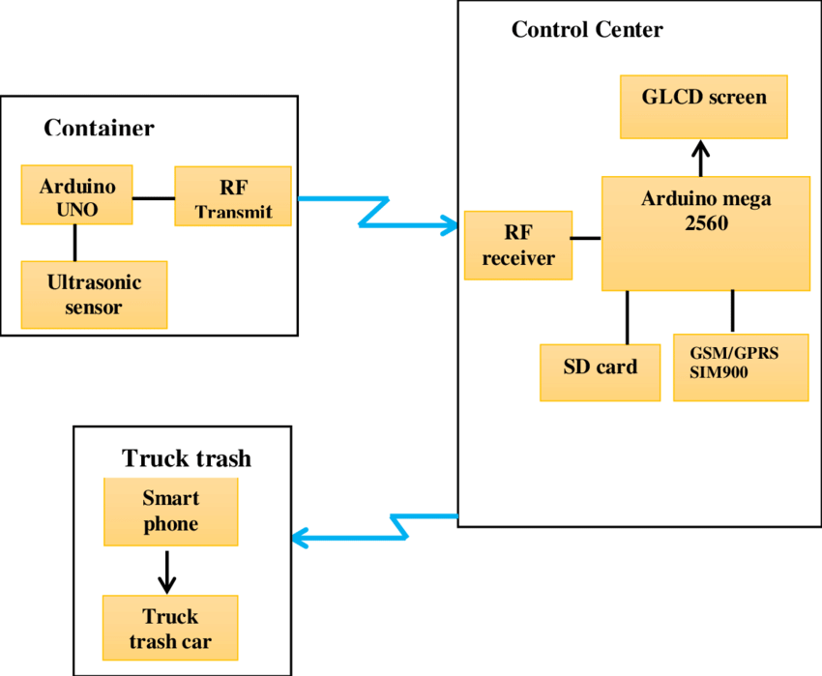The envisioned autonomous refuse retrieval automaton will seamlessly fuse cutting-edge sensor technologies, articulate robotic appendages, and intricate microcontrollers in a harmonious symphony aimed at accomplishing its predetermined goals [2]. The procedural approach encompasses a meticulous blend of innovative engineering solutions, revolutionary programming paradigms, and an unwavering commitment to precision.

## **2.1 System Architecture**

The system architecture of an autonomous robot system prototype is crucial for managing complexity and ensuring efficient performance. In the context of designing and building an autonomous robot system prototype.

**1. Arduino Nano (Atmega 328P)**

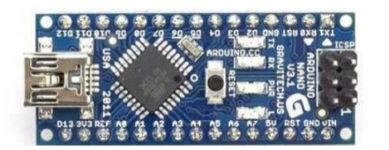The Atmel 8 bit microcontroller merges 32KB flash memory with the capabilities of read-while-write, 2 KB SRAM, the 32 general purpose working registers, three pliable counters/timer, external and internal interrupts, a SPI serial port, 6-channel A/D converter, programmable watchdog timer as well as the five software power saving modes.

**Fig 3. Shows Arduino Nano Atmega 328P**

**2. Ultrasonic Sensor(HC-SR04)**

Fig shows the ultrasonic sensor. This sensor is being placed in the fixed pole part of garbage bin, so as to intimate about the garbage level of the fixed garbage part.

**Fig 4. Shows ultrasonic ranging sensor**

**3. Infrared Sensor**

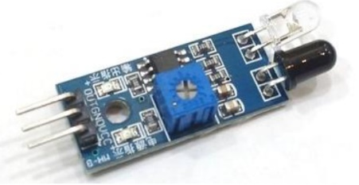Infrared sensor here used is to control the path of garbage collector robot. It is also used to encounter the extent of the muck in the garbage car. Fig shows the diagram of infrared sensor.

**Fig 5. Shows infrared sensor**

**4. RF Module (433MHz)**

RF Module is basically used for conveyance purpose over ranges, mainly to indicate the garbage car about the level of the fixed dustbin. If the dustbin is completely filled it will send a signal to the garbage car part, and the garbage car will come and empty the dustbin instantly.

**Fig 6. Shows the RF Module for transmission purpose**.

## **2.2 Improvement of projected system over existing system.**

• Real-time info on the extent of the trash in dustbin.

• Saves environment and money.

• Ensures that the dustbin is empty and not overflowing with garbage.

• Saves life of workers from any type of harmful or infected objects in the garbage.

• Intelligent management of the services in the various areas.

• Effective usage of dustbins.

• Waste management can be done in a faster and in a smarter manner.

# **3. Time Schedule:**

**Table-1 (Time Shedule: Year 2023)**

|  |  |  |  |  |  |  |  |  |  |
| --- | --- | --- | --- | --- | --- | --- | --- | --- | --- |
| **Activity** | **W1** | **W2** | **W3** | **W4** | **W5** | **W6** | **W7** | **W8** | **W9** |
| Project Initialization |  |  |  |  |  |  |  |  |  |
| Design Phase |  |  |  |  |  |  |  |  |  |
| Implementation |  |  |  |  |  |  |  |  |  |
| Safety and Testing |  |  |  |  |  |  |  |  |  |
| Hardware Finalization and Optimization |  |  |  |  |  |  |  |  |  |
| Documentation and Testing |  |  |  |  |  |  |  |  |  |
| Pilot Development |  |  |  |  |  |  |  |  |  |
| Project Review and Conclusiion |  |  |  |  |  |  |  |  |  |

# 

# **4. Project Cost :**

**Table-2 (Project Cost)**

|  |  |  |  |
| --- | --- | --- | --- |
| Name of Cost | Unit Prize | Unit | Total Cost (Taka) |
| Ultrasonic Sensor | 2000 | 1 | 2000 |
| Infrared Sensor | 1000 | 3 | 3000 |
| Camera | 2000 | 2 | 4000 |
| Microcontroller | 3000 | 1 | 3000 |
| Power Supply | 2000 | 1 | 2000 |
| Battaries | 1000 | 3 | 3000 |
| WiFi Module | 2000 | 1 | 2000 |
| Simulation Software | 10000 | 1 | 10000 |
| Software Engineers | 20000 | 1 | 20000 |
| Machine Learning Specilalist | 20000 | 1 | 20000 |
| Testing Equipment | 1500 | 5 | 7500 |
| Total Cost | | | 76500 |

# **5. Conclusion**

This project is devised to render the task of muck collection from differing places and then dump it at a particular location from where the muck is conveniently taken for the action of reusing and recycling. By intimating the notification of level of garbage filled in the fixed dustbin to the garbage car, we can decrease the number of trips of the garbage collecting vehicle, thus saving power and money. Also by introducing the RF Module on the fixed dustbin part, we are making this system fully automated. Thus, by implementing this project in real time scenarios we can make a contribution towards the enhancement of Smart City Project.

# **6. References**

[1]. Maya Chavan, T.R. Pattanshetti, “Survey on Municipal Waste Collection Management in Smart city”, in International Research ,Journal of Engineering & Technology, 2018.

[2]. Johnson, M., et al. "Robotics and Automation for Waste Collection: Challenges and Opportunities," Conference on Automation and Robotics, pp. 45-56, Year.